### Phase shifter of RC and RL circuit



#### Lab Project: Phase shifter

***Submitted By***

**Muhammad Mitwas (FA21-BCE-017/ATK)**

**Comsats University Islamabad, Attock Campus**

**(2021-2025)**

**Table of Contents :**

1. **Objective**
2. **Introduction**

**2.1 What is phase shifters.**

**2.2 Types of phase shifters.**

**2.3 How phase shifter is accomplished.**

**2.4 RC Circuit**

**2.5 RL Circuit**

**3. Circuit Components and specifications**

**3.1 Resistor**

**3.2 Capacitor**

**3.3 Transformer**

**3.4 Bread Board**

**4. Circuit and Simulation**

**4.1 Circuit and Simulation**

* 1. **Block Diagram**

**4.3 Mathematical**

**4.4 Hardware Output**

**5. Conclusion**

**5.1 Advantages**

**5.2 Disadvantages**

**5.3 Conclusion**

**Objective:**

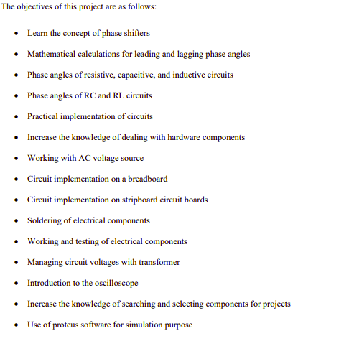

1. **Introduction:**

* **What is a phase shifter :**

An RC/RL phase shifter circuit is a type of electronic circuit that is used to shift the phase of an input signal by a specified amount in the result of an output. It works by introducing a delay in the signal path, which results in a phase shift. The amount of phase shift can be controlled by adjusting the values of the resistors, capacitors, and inductors (coils) used in the circuit.Phase shifter can provide precise control of the phase shift, and are often used when a constant or highly accurate phase shift is required.

* **Types of phase shifter :**

There are mainly two differentnt types of phase shifters ::

* Leading phase shifter.
* Lagging phase shifter.
* **How Phase Shift is accomplished :**

Phase shifters can be implemented using electronic components such as capacitors, inductors, and resistors. The combination of RL or RC would produce both leading and lagging output w.r.t input. These signals can be voltage or current signals. There are 4 main combination of Rc and Rc circuit.

* **RC circuit :**

In Rc circuits, resistor and capacitor are connected in series with each other. We can obtain output at both w.r.t output required.

* Across Capacitor is we want a lagging output.
* Across Resistor if we want a leading output.
* **RL circuit :**

In Rl circuits, resistor and inductor are connected in series with each other. We can obtain output at both w.r.t output required.

* Across resistor is we want a lagging output.
* Across inductor if we want a leading output.

1. **Circuit Components ::**

Following are the components that are used for making simple phase shifter circuit ::

|  |  |  |  |
| --- | --- | --- | --- |
| **SL.NO.** | **NAME OF THE COMPONENT** | **SPECIFICATIONS** | **QUANTITY** |
| **1.** | Resistor | Variable having range ( 0k- 10k) | 1 |
| **2.** | Capacitor | 0.66uF or 2 (0.33 uF) connected in parallel | 1 |
| **3.** | Transformer | Step-down from 220V to 9V | 1 |
| **4.** | Bread-board |  | 1 |

* **Component’s Specifications ::**

Following are brief specification of the component used ::

1. **Resistor::**

A resistor is a passive electronic component that is used to oppose the flow of electric current in a circuit. It is represented by the symbol R in circuit diagrams .A resistor has a specific resistance value, measured in ohms (Ω). This value determines the amount of opposition to the flow of current.

A variable resistor, also known as a potentiometer, is a type of resistor that can be adjusted to change its resistance value. It consists of a resistive element and a sliding or rotating contact that can be used to adjust the resistance.

**Specifications:**

* Track Resistance: 10K ohm.
* Resistance Tolerance: ± 5%
* Temperature Coefficient: ± 100ppm/°C.
* Operating Temperature range : -40 to 80 oC

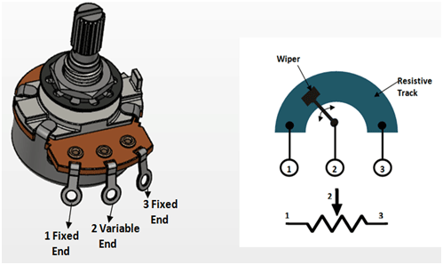

1. **Capacitor ::**

A capacitor is a passive electronic component that stores electrical charge. It is composed of two metal plates separated by an insulating material called a dielectric. The amount of electrical charge that a capacitor can store is determined by its capacitance, which is measured in units of Farads (F).

Capacitors are used in phase shifter circuits to introduce a phase shift between the input and output signals.This time delay is known as the capacitor's time constant. By adjusting the value of the capacitor in a phase shifter circuit, it is possible to control the amount of phase shift that is introduced between the input and output signals.

##### Specifications:

1. Capacitance: 0.33uF.
2. Tolerance: K(±10%).

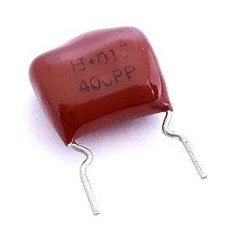

1. **Transformer :**

A transformer is an electrical device that is used to transfer electrical energy between two or more circuits through electromagnetic induction. It consists of a primary winding, a secondary winding, and an iron core. When an alternating current (AC) voltage is applied to the primary winding, it creates an alternating magnetic field in the core. This alternating magnetic field then induces an AC voltage in the secondary winding.

A step-down transformer is a type of transformer that is designed to reduce the magnitude of the AC voltage applied to the primary winding. In the phase shift project, we use step-down transformer to lower the voltage upto 12V because the element are of lower value and could not stand high voltage of 220V.

Even after using transformer, our elements were burnt 2 to 3 times which was a difficult task to do.

**Specifications ::**

* Step-down Centre tapped Transformer
* Input Voltage: 220V AC at 50Hz
* Output Voltage: 24V, 12V or 0V
* Output Current: 1A

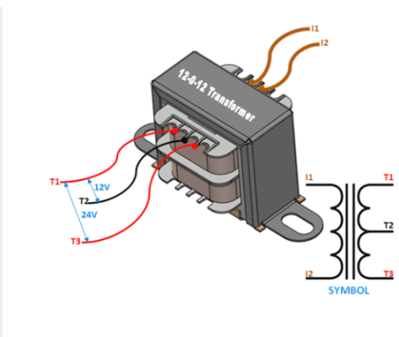

1. **Bread-board ::**

AA breadboard is used to build and test circuits quickly before finalizing any circuit design. The breadboard has many holes into which circuit components like ICs and resistors can be inserted. A typical breadboard is shown below:

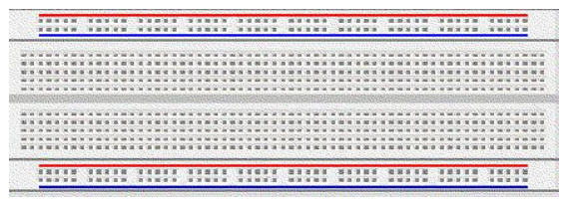

The bread board has strips of metal which run underneath the board and connect the holes on the top of the board. The metal strips are laid out as shown below. Note that the top and bottom rows of holes are connected horizontally while the remaining holes are connected vertically.

1. **Circuits & Simulation**
2. **Circuit ::**

In RC circuits, if we want to calculate leading output w.r.t input :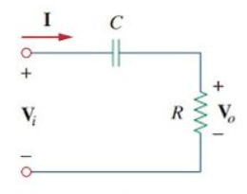

If we take Vi as input and Vo as output, we will get a leading ouput.

In second case,

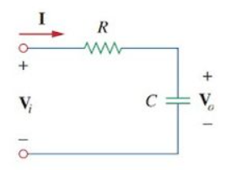

In this case, we would get a lagging output. The resultant phase sift in both cases are ::

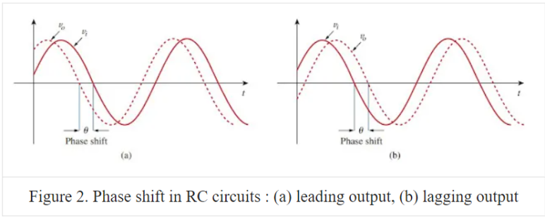

**Simulation :**

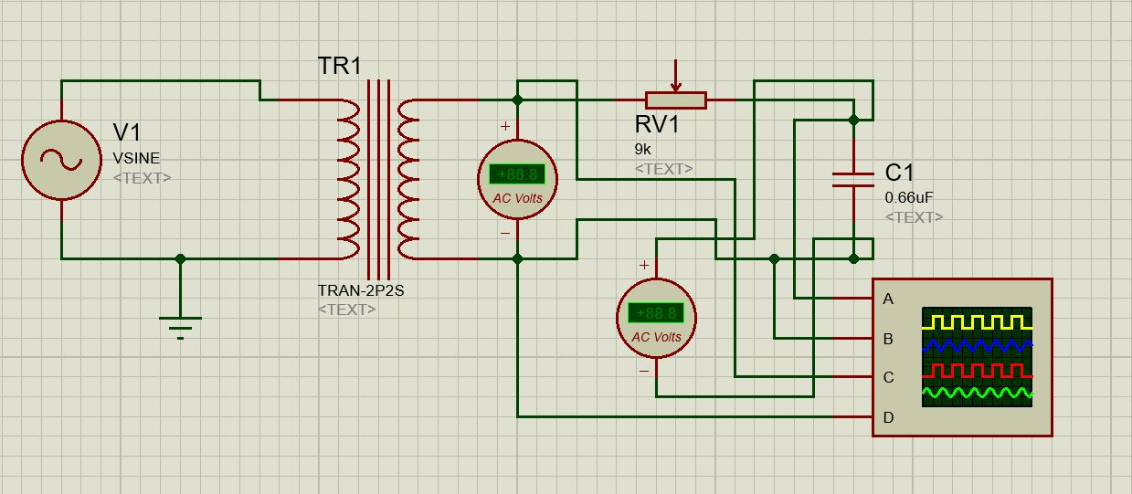

1. **Block Diagram :**

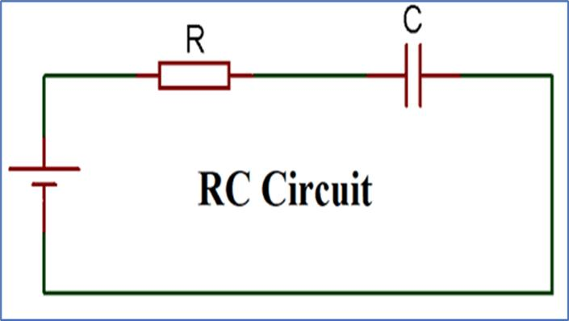

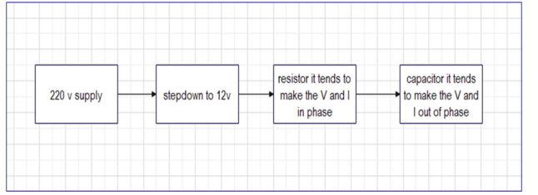

1. **Mathematical Calculations:**

Before making any project, it includes some mathematical calculations based on which the components are selected. so in our case the major components were the resistor, and capacitor.

Formula for phase angle=> Q=Tan-1 (X/R)

1. **Hardware output :**

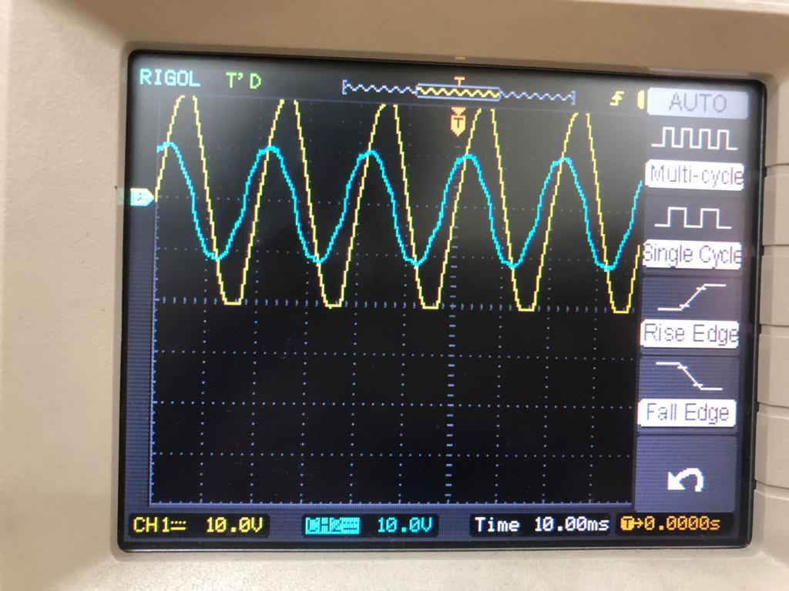

1. **Conclusion and References**
2. **Advantages :**

Following are the advantages of RC circuit ::

* RC phase shifter circuits are relatively simple and easy to design and implement, compared to other types of phase shifters.
* RC phase shifters have a low level of distortion, which means that they do not significantly alter the shape or quality of the input signal.
* RC phase shifters are generally less expensive to design and implement than other types of phase shifters, due to the simplicity of their design.
* RC circuits are compacts ans smaller in size.

1. **Disadvantages :**

Following are the disadvantages of RC circuit ::

* RC phase shifters are generally only effective over a limited frequency range, typically below 1 MHz.
* The capacitance of the capacitors used in an RC phase shifter circuit can vary with temperature, which can affect the phase shift introduced by the circuit. The only solution is to use temperature-stable capacitors, but this adds to the cost of the circuit.
* RC phase shifter circuits are generally limited to introducing phase shifts of 90 degrees or less. Generaly if we wanr to an angle of 90, we prefer combining two phase shifters

in parallel with each other.

1. **Conclusion ::**

It is generally concluded that RC phase shifter circuits are simple, low-cost, and effective for introducing small phase shifts over a limited frequency range.They are well-suited for applications where a constant phase shift is required over a wide range of frequencies. Phase shifter are limited to introducing phase shifts of 90 degrees or less and are only effective over a limited frequency range. They also have poor impedance matching and are sensitive to temperature changes, which can affect the phase shift introduced by the circuit.